Reminders
VILLAGE OF
HILLS
H
H
HANLEY

Building a better community
BOARD MEMBERS:
CHAIRWOMAN- DIANA WHITE
TREASURER- BETTYE MITCHELL POLICE COMMISSIONER- GREGORY ROBINSON
PARK & TREE COMMISSIONER- LAMANDA GOODRICH HEALTH COMMISSIONER- HELENA TAYLOR
PUBLIC WORKS COMMISSIONER-
JEFFREY WALTON BUILDING COMMISSIONER- TIRAN GREER
PUBLIC RELATIONS COMMISSIONER- ANNETTE HARRISON
STREET COMMISSIONER- MIA SHIELDS

A friendly neighborhood reminder:
Animal Tags: are due on March 1st. Please bring current rabies certificate for pet. Dogs/cats tags are $8.00. There is a $5.00 late fee for each month you do not have an animal tag.

~ Please report any dogs unleashed and without owner, running free in community to the St. Louis County Police Department - 911 or Non-emergency - 314-889-2341 or 636-529-8210
Citizens are encouraged to use the following number to report drug activity that they have observed to the St. Louis County Police Department Bureau of Drug Enforcement. This can be done without identifying yourself. You may also provide information by calling 314-863-DOPE (3673)
Be a great neighbor and friend; if you see a suspicious person or persons lurking in the neighborhood, around homes and in the parks, please call St. Louis County Police. Let’s keep each other safe!
Arthur Brown and Stanley Taylor will be volunteering for the Neighborhood Watch Program for the east side of the Village. We need volunteers to start a Neighborhood Watch Program for the west side of the Village.

Office Hours:
Monday –Friday 9:00am - 5:00pm
Village
Phone Number:
314-725-0909

@ The Village of Hanley Hills
Or visit us online at
www.thevillageofhanleyhills.com
Monthly Meetings
Our regular schedule meetings are as follows:
~Court days are the 1st and 3rd Tuesdays of the month at 6:00 pm. doors open at 5:30 pm.; if an election is held on that Tuesday; court will be held the 1st Wednesday. The Court Dept. will not release any court information by phone; you will need to come to Village Hall.
~The Neighborhood Watch meets on the 3rd Thursday of every month at the Village Hall @ 6:00pm. Come out to join concerned citizens, for the safety of our community!
~The Board of Trustees Public Meeting is held at 6:30 pm. on the 3rd Thursday of the month. The public comments (3 mins each) are welcomed and permitted before Village business.

Affinity Program Healthcare Center - now located in Normandy High School. Tuesday& Thursday 7am-4pm
Family Engagement Liaison - now available for the Normandy school District. This service will address family issues with resources in real time. Support in a real way with current and long term resources through an effective delivery system.
Beyond Housing Community Survey –
- What do you love about your community?
- If you had three wishes for Hanley Hills what would they be? Call in your answers to 314-725-0909

*The St. Louis area has a work force shortage. A position has been established to address to void by the Career & College Coordinator. They will help prepare students to enter training programs for specific trades in demand for the STL region. Normandy Schools Collaborative Rocks!
* 5 Normandy students have been chosen for the “All Star High School Chorus” - Congratulations!
*Normandy Schools Collaborative has 4 schools ranked “Americas Healthiest Schools” Way to go!

Normandy
Schools
Collaborative
Has received national recognition!
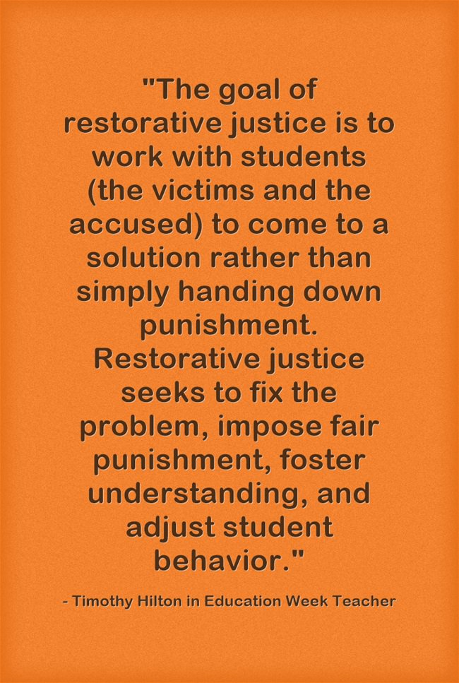

What is restorative Justice?
What is a SRO Program?
School Resource Officers (SROs) and the School Community Collaboration between law enforcement officers and schools is an important step in increasing school safety. The concept of having law enforcement officers involved with schools stems from the practice of community policing. Community policing utilizes the assistance of community members for identifying and prioritizing problems and developing solutions. The school community may involve the following: superintendents, administrators, principals and assistant principals, teachers and assistants, counselors, school nurses, school social workers and psychologists, bus drivers, custodians, maintenance and cafeteria personnel, students and parents. In a School Resource Officer program the members of the school community partner with the law enforcement officer assigned to their school in order to create a setting that is safe and secure, with a focus on prevention and early intervention activities.

VILLAGE TRUSTEES SPEAK:
CHAIRWOMAN- DIANNA WHITE- “Senior Huggable” is a new service available for seniors in Hanley Hills; for example errands, doctor’s appointment and etc. Please call 314-725-0909 or Dianna White at 314-813-7204
PUBLIC WORKS- JEFFREY WALTON- Team up Hanley Hills will be available for raking leaves (you provide the bags), ice and snow removal for seniors and disabled residents. Call Team up Hanley Hills at 314 725-0909 or 314 374-3519. This volunteer service is free and based on availability of volunteers. We ask that you kindly give a donation to the youth, for their time and community service efforts.
Please be advised of the danger of electrical shock by pulling and swinging on the electrical wires under the large pavilion in the park! DO NOT TOUCH!
I am Trustee Jeffrey Walton and I will be your host for the Annual Halloween Party here at the Village City Hall starting at 6:00pm until all the treats run out! We will have music, food, and a whole lot of Spooktacular fun!
PUBLIC RELATIONS- ANNETTE HARRISON- Please check our community poster display cases for announcements of public information and community events. See the dates and time in Community News and Events. See our FB page and our village website often for Village of Hanley Hills and St. Louis regional news and events. We have a new button on our website opening page, Hot Topics will feature surrounding community and our events for a quick glance.
Residents please report any vandalism to HH property, call 314-889-2341
The Hanley Hills Village office will be closed on the following national holidays: New Year’s Day, Martin Luther King Day, Presidents Day, Memorial Day, Independence Day, Labor Day, Veterans Day, Thanksgiving and the day after, Christmas Day and the day after Christmas. (R.O.2012:117.160; CC1987: 23.170; Ord. 810:1, 9-20-01
TREASURER- BETTYE MITCHELL- My role as treasurer is to preserve the Village of Hanley Hills’ financial assets including providing insight and direction for financial decision making.
CAPTIAL IMPROVEMENT TAX FUND ACCOUNT - $548,145.34 CAPITAL IMPROVEMENT TAX FUND ACCOUNT - $12,500.00
GENERAL FUND ACCOUNT - $205,599.63 GENERAL FUND SWEEP - $12,530.00 COURT BOND ACCOUNT - $2,969.81 TOTAL: $781,744.78
For Your Information:
VILLAGE CLERK – DOROTHY MATTHEWS – We need volunteers for the creek clean up and honeysuckle cut at Hanley Hills on October 20, 2018. Interested in volunteering, please call City Hall at 314-725-0909.
Registration- 8:15am - at Hanley Hills City Hall parking lot
8:30am - Mandatory Safety Briefing
8:45am – work starts
11:30am – work ends
RESIDENT COMMENTS: Ms. Sandy Bean, “It breaks my heart that the village will not be having any holiday celebrations for our children.”

